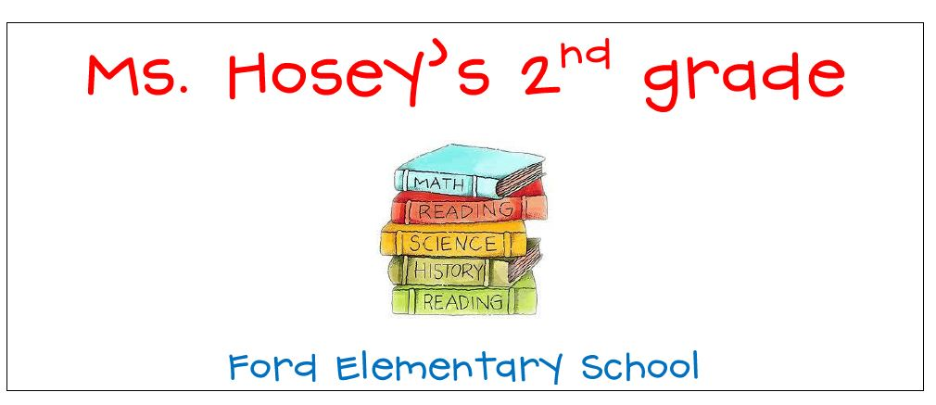
7:15-7:50 Arrival, Morning Work
7:50-8:00 Announcements/Attendance
8:00-8:15 STEM
8:15-9:00 Specials
Day 1 – PE/Day 2 – Art/Day 3 –P.E./
Day 4 – Music/Day 5 – P.E./Day 6-STEM

9:00-9:30 Bathroom/snack/morning meeting

9:30-11:30 Daily 5 Literacy Block/Writer’s Workshop
11:30-11:40 Clean-/Restroom
11:42-12:12 Lunch/Table 5/6
12:12-12:25 Number Talk
12:25-1:20 Daily 3 Guided Math
1:20-1:45 Recess
1:45-2:00 Integrated Science/Social Studies/Health
2:00-2:15 Calendar/Pack
2:15-2:30 Afternoon Announcements/Dismissal

